**Phase2 – Practice Project: Assisted Practice**

Running Test from the Console

* Right click on the java class file🡪Go to Properties 🡪 copy the path of the file location

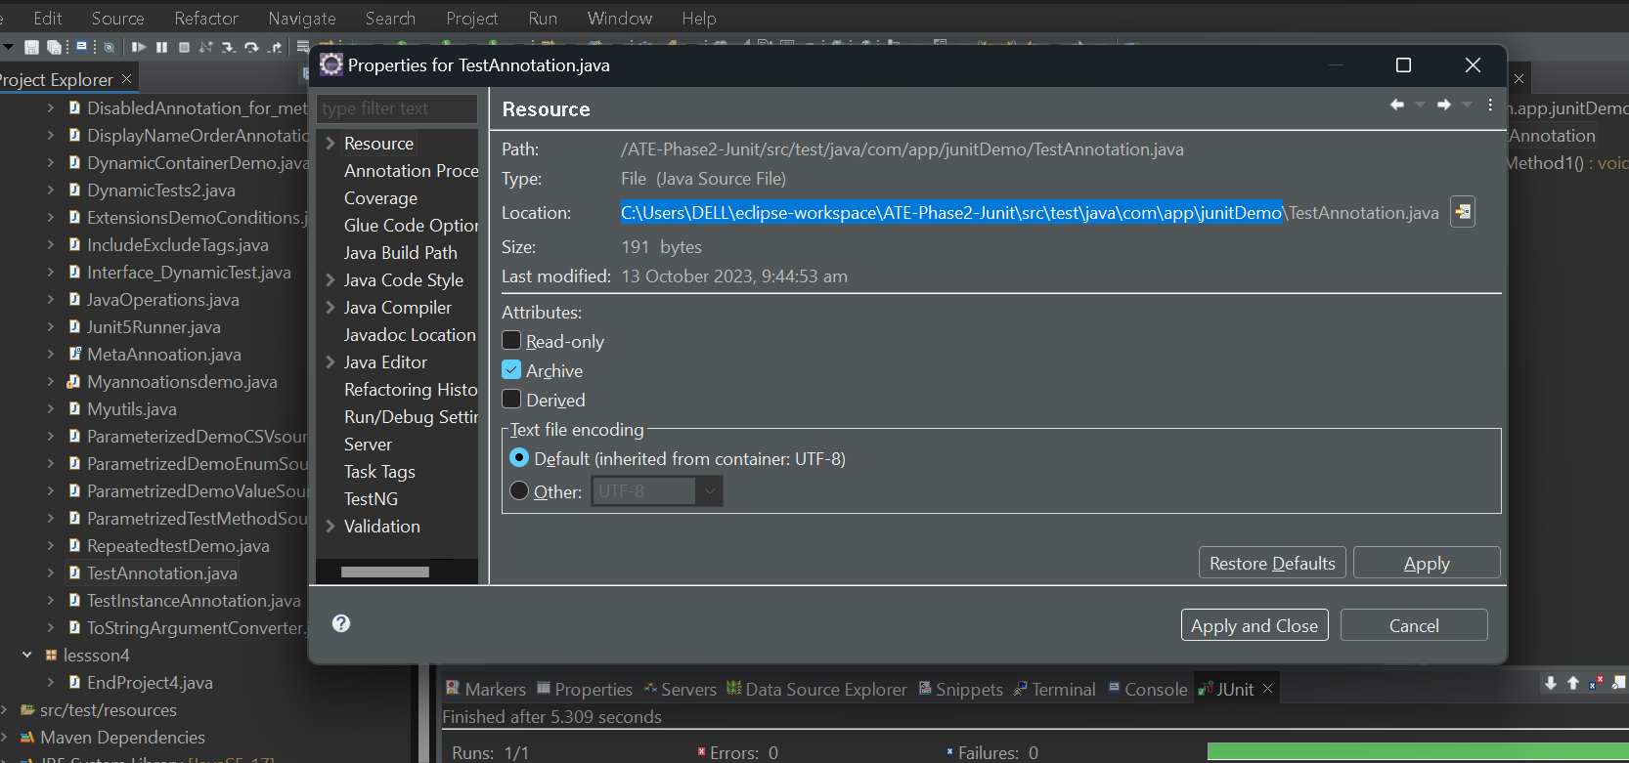

* Open the command prompt in your laptop and copy the path but remove the filename at the end

Like this cd C:\Users\DELL\eclipse-workspace\ATE-Phase2-Junit\src\test\java\com\app\junitDemo

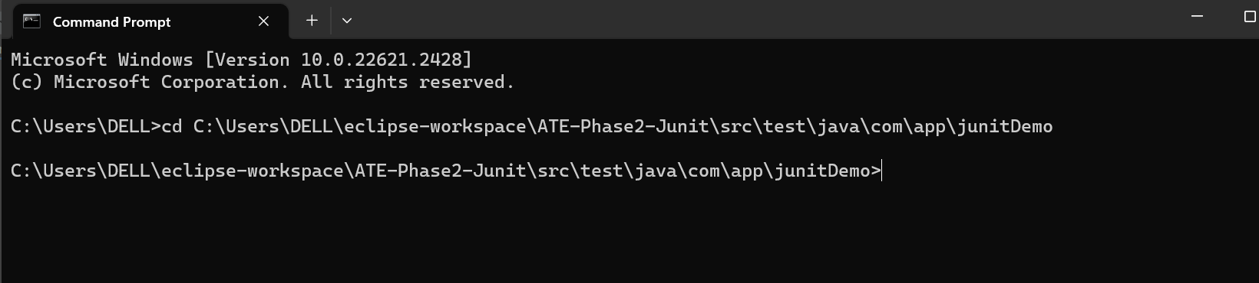

* We also need the path of Junit Jar file on your project. We need to get that path from eclipse project
* Right click on maven dependency
* folder > right click on Junit jar and go to properties
* Go to java source attachment and copy the path as show below

C:/Users/DELL/.m2/repository/org/junit/jupiter/junit-jupiter-api/5.9.3/junit-jupiter-api-5.9.3-sources.jar

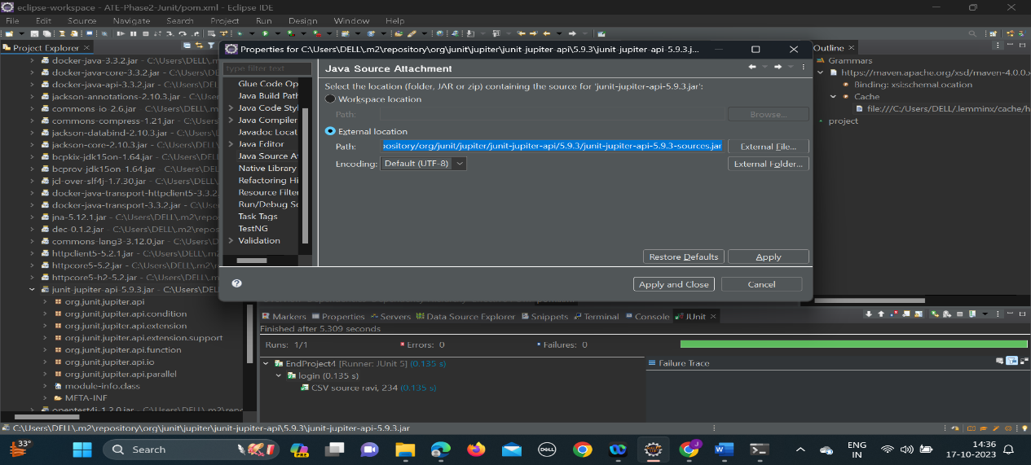

* Enter the command

# java -cp C:/Users/DELL/.m2/repository/org/junit/jupiter/junit-jupiter-api/5.9.3/junit-jupiter-api-5.9.3-sources.jar;. TestAnnotation.java

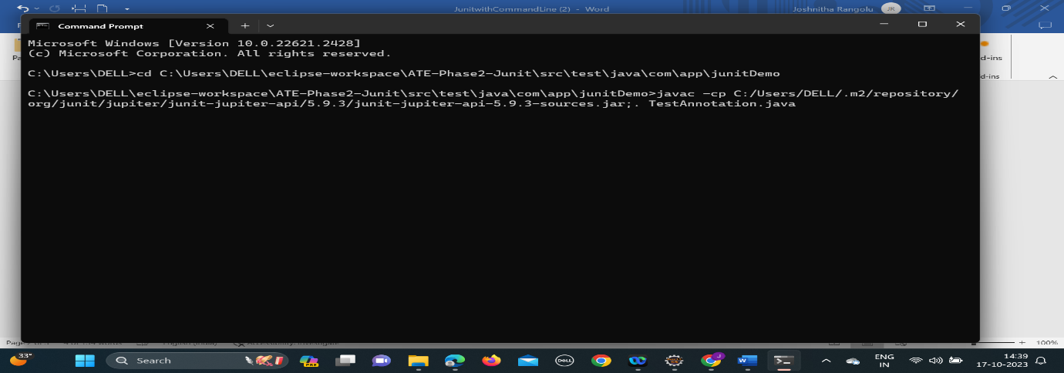

* You will get error, ignore them

# java -cp C:/Users/DELL/.m2/repository/org/junit/jupiter/junit-jupiter-api/5.9.3/junit-jupiter-api-5.9.3-sources.jar TestAnnotation.java

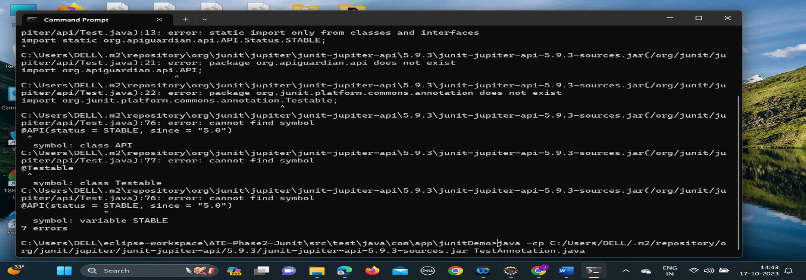

You will get error. Submit the same